Student Name
Institution
Date

Albert Park tunnels
This archeological site is found in Auckland, New Zealand. These tunnels were constructed during the Second World War to serve as air-raid shelters for over 22,000 New Zealand soldiers. Being located underneath a volcanic mountain, the tunnels were made up of natural lava caves beneath the dormant volcanic cone.
Source: Jock Phillips, 'Bridges and tunnels - Road and utility tunnels,' Te Ara - the Encyclopedia of New Zealand, http://www.TeAra.govt.nz/en/photograph/23660/entrance-to-albert-park-tunnels (accessed 4 August 2021). https://teara.govt.nz/en/photograph/23660/entrance-to-albert-park-tunnels
Image 1

Concept Art. Photo credit: Albert Park Tunnels Website
Te Wairoa – "The Buried Village
The Buried Village of Te Wairoa is located near Lake Tarawera in New Zealand. The site was formed when Tarawera mountain erupted, clearing the entire countryside surrounding the mountain. The site was characterized by fumaroles, boiling muds, and hot springs inside a volcanic caldera formed during the eruption.
Source: Blindcolour, R. (2021). Te Wairoa Buried Village. Accessed online at (Aug 2021). https://www.atlasobscura.com/places/te-wairoa-buried-village
Image 2
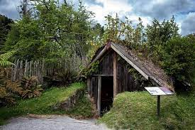
The Burid Village of Te Wairoa
Lofotr Viking Museum
The Borg in Lofoten archeological site is located in Lofoten, Norway. The Lofoten is a thousand-year-old log house stretching for almost 83m. it contains the history of the Norwegian Viking community. The longhouse became a world archeological site in 800AD and became popular in 1999 when it was open as a tourist attraction site in Norway.
Source: Egeland, E. (2021). A complete Guide to Lofotr (Lofoten’s Viking Museum)- Ready for the Vikings? Accessed online at (Aug 2021). https://nerdnomads.com/lofotr-viking-museum
Image 3

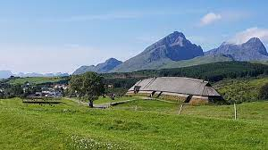
Lofotr Viking Museum
Borre mound cemetery
Borre mound Cemetery is located in Borre, Norway. The cemetery is a great area with burial mounds in Scandinavia. They provide an important history of the Merovingian period before the Viking period in Norway. The archeological site boomed in 1852. Local builders used single mounds as gravel pits.
Source: Borrehaugene (Store norske leksikon)
Image 4
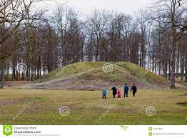
Viking Graves at Borre Mound Cemetery
Gokstad ship burial
Gokstad Ship Museum is found in Vestfold, Norway. The ship is a graveyard for a powerful man in the Viking community. It, therefore, serves as a reminder to the community and the Vikings' countrymen. The ship's excavation took place in 1900, a period that served as the height of the museum.
Source: "Skjelettet fra Gokstadskipet ny vurdering av et gammelt funn" (2008) by Per Holck, Michael Quarterly, 5(4), 292-304. Accessed online at (Aug 2021). https://penelope.uchicago.edu/~grout/encyclopaedia_romana/britannia/anglo-saxon/maldon/gokstad.html
Image 5
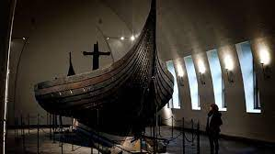
Gokstad- Museum of Cultural History

Oseberg ship burial
The Oseberg ship museum is found in Tonsberg, Norway. It is an important historic and the most beautiful burial location for the Vikings. The ship was excavated in 1904 and re-assembled for exhibition at the Viking ship museum, Oslo, where it is on display for the entire world to see.
Source: Bischoff, V. (2021). New Oseberg ship, reconstruction of the hull form. Accessed online at (Aug 2021). https://www.vikingeskibsmuseet.dk/en/professions/boatyard/building-projects/the-oseberg-ship

Image 6
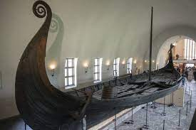
Norway excavates a Viking longship fit for a king
Tune ship burial
Tune ship museums are found on the Nedre Haugen Farm in 1867 outside Fredrikstad, Norway. Tune ship was among the 1st Vikings to be excavated. Both the discovery and excavation attracted a great deal of interest. The museum is sixty meters in diameter, making it the country's greatest burial mound.
Source: https://www.khm.uio.no/english/visit-us/viking-ship-museum/gjellestad-ship/tune-ship/
Image 7
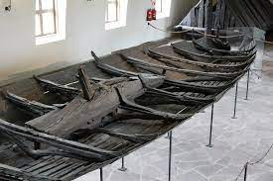
Viking Tune Ship: The Very First Viking ship
Biskupin Iron Age
The Biskupin Iron Age was found in 1933 in central Europe. Thus, it is 2700 years old. The archaeological site of the Biskupin ship started in 1934 and was sustained till the outbreak of WWII and then resumed in 1946. The wood was stored well due to its saturated state, thus leading to the repossession of a brilliant amount and quality of info.
Source: https://www.encyclopedia.com/humanities/encyclopedias-almanacs-transcripts-and-maps/biskupin
Image 8
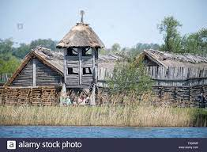
Archeological site and a life-size model open- air museum of iron age fortified
Giecz Middle Ages
Giecz is identified as a small village in central Welkopolska. Its trade settlements lie in the remains of the 11th century. A nearby, mighty defensive stronghold together with this settlement and an adjacent graveyard is Gneizno and Poznan. Giecz was discovered as the main political and economic center of the newly emergent polish state.
Source: http://www.slavia.org/slavia_project.php?go=excavation_giecz
Image 9
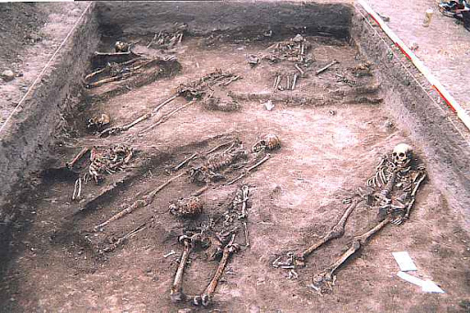
Slavia: Polish History and Culture
Augusta Raurica
Augusta Raurica is found on the Rhine River, and it is also a former Roman colony and city. It is 7miles east of the modern swiss of Basel amongst the two towns of Kaiseraugst and Augst. It was discovered in 90BCE-15BCE, and it is the oldest museum constructed along the Rhine. In a short period, the museum grew into a city and attracted many residents. However, in spite of the rapid growth, they were attacked by the Alemanni earthquake.
Source: Wiener, B.J. (2018). Augusta Raurica. Accessed online at (Aug 2021). https://www.worldhistory.org/Augusta_Raurica/
Image 10
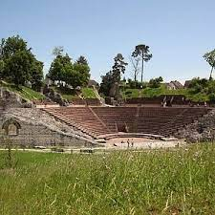
Augusta Raurica (Augst)
Aventicum (Avenches)
Aventicum used to be the capital of the Helvetti during the Roman time. Later it extended a large portion which is now identified as Switzerland. The Roman city, which once boasted more than 20000 residents, was founded on the small community of Avenches in Cantron. The museum started in the 17th century.
Source: De Pury-Gysel, A. (2011). Aventicum (Avenches), capital of the Helvetii: A history of research, 1985-2010. Part I. Early Roman Aventicum and its origins. Journal of Roman Archaeology, 24, 7-46. doi:10.1017/S1047759400003263. Aceessed online at (Aug 2021). https://www.cambridge.org/core/journals/journal-of-roman-archaeology/article/abs/aventicum-avenches-capital-of-the-helvetii-a-history-of-research-19852010-part-i-early-roman-aventicum-and-its-origins/49B8AF09B625A41B822B85A992F89208
Image 11
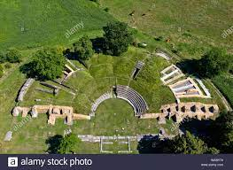
Roman theatre of Aventicum
Vindonissa (Windisch)
Vindonissa was located in Switzerland, and it only speciliases the history of the Roman legions. The newest exhibition invited visitors to learn more about the first one hundred years of readings and writings. The public and private roman slates were written 2000 years ago, and they are the ones guiding visitors through different sections.
Source: Tripadvisor. (2016). Vindonissa Museum. Accessed online at (Aug 2021). https://www.tripadvisor.com/Attraction_Review-g1474347-d6209304-Reviews-Vindonissa_Museum-Brugg_Canton_of_Aargau.html
Image 12
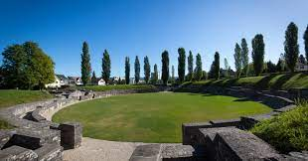
Roman sites- Vindonissa Legionary Trail
Sacred Ridge
Sacred Ridge was located in southwestern Colorado about 1200 years ago. It indicates the new evidence and also shows what happened during that time. Sacred Ridge was excavated in 2005 near Durango town. First, it was used as a settlement where a collection of pithouses was found not far from the friendly communities. However, later, conflicts arose that they are still trying to solve together.
Source: Pastino, D.B. (2018). Evidence of Hobbling, Torture Discovered at Ancient Massacre Site in Colorado. Accessed online at (Aug 2021). http://westerndigs.org/evidence-of-hobbling-torture-discovered-at-ancient-massacre-site-in-colorado/
Image 13
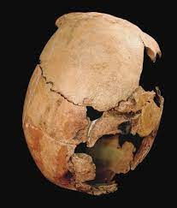
Massacre at Sacred Ridge
Serpent Mound
Serpent Mound, also identified as Great Serpent Mound, is located in Peebles, Ohio, USA, and it enclosed a statue mound in 1348 and is411 meters shape of a serpent. Globally, it is the largest statue mound of the snake. Firstly, it has been important to Native Americans, but later excavations said the natives of Fort Ancient culture constructed it.
Source: Mark, J.J. (2021). Serpent Mound. Accessed online at (Aug 2021). https://www.worldhistory.org/Serpent_Mound/
Image 14
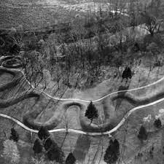
Serpent Mound- HISTORY
Snaketown
Snaketown is found in the south of Phoenix on the Gila River. The snaketown was excavated in 1930. Hohokam are sedentary agriculturists residing in central and southern Arizona. They are famous for their enormous irrigations system, large reimbursements, public fortifications, and beautiful dexterities.
Source: https://www.archaeologysouthwest.org/projects/snaketown-heritage/
Image 15
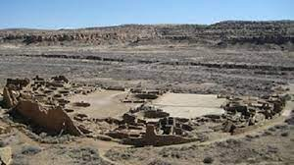
Arizona: Hohokam Pima National Monument (U.S. National Park Service )
Crystal River Archeological Park
The archeological park is located in the Citrus county of Florida, USA. The name crystal river is derived from the fact that it is located on the bank of River Crystal of Florida. The site was commonly used during the period between 800BCE-1500CE by cultures that valued ceremonial practices and mound burial. These cultures include the Santa Rosa-Swift Creek culture, the Deptford culture and the Fort Walton culture (Wikipedia, 2021).
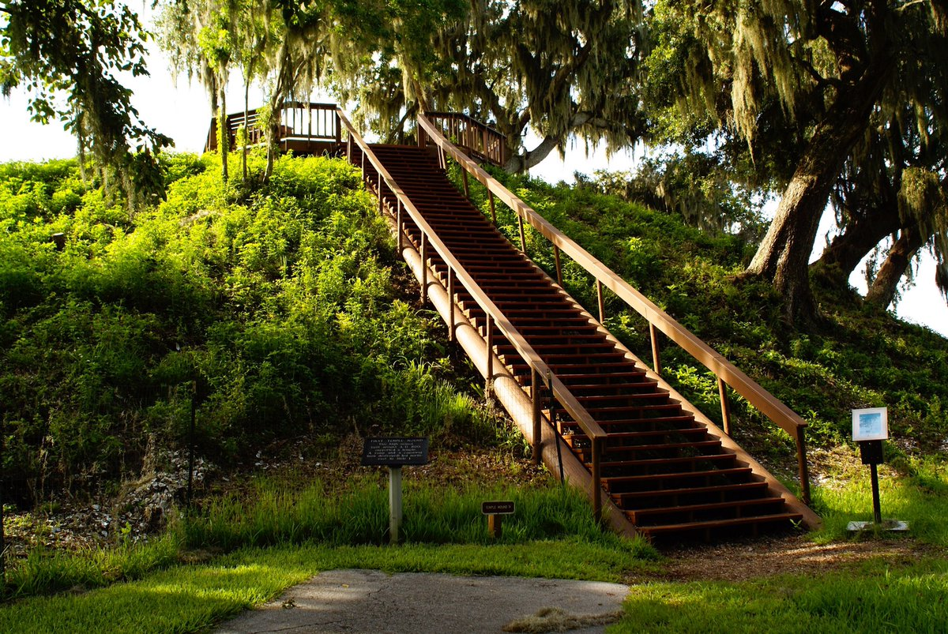
Sources
Feder, K. (2017, June 4). Crystal River Archeological State Park [Photograph]. https://twitter.com/fiftysitesbook/status/871138250580267009
Wikipedia contributors. (2021, March 29). Crystal River Archaeological State Park. Wikipedia. https://en.wikipedia.org/wiki/Crystal_River_Archaeological_State_Park

Chichen-Itza Botanical Garden
The Chichen-Itza is a huge city that is located in the Yucatan state of Mexico, within the municipality of Tinum. It is located in the lowlands of the Yucatan Peninsula in the south east of Mexico. The city was built during the pre-Columbian era by people of the Mesoamerican culture and was at its height in the period between AD600-1200.
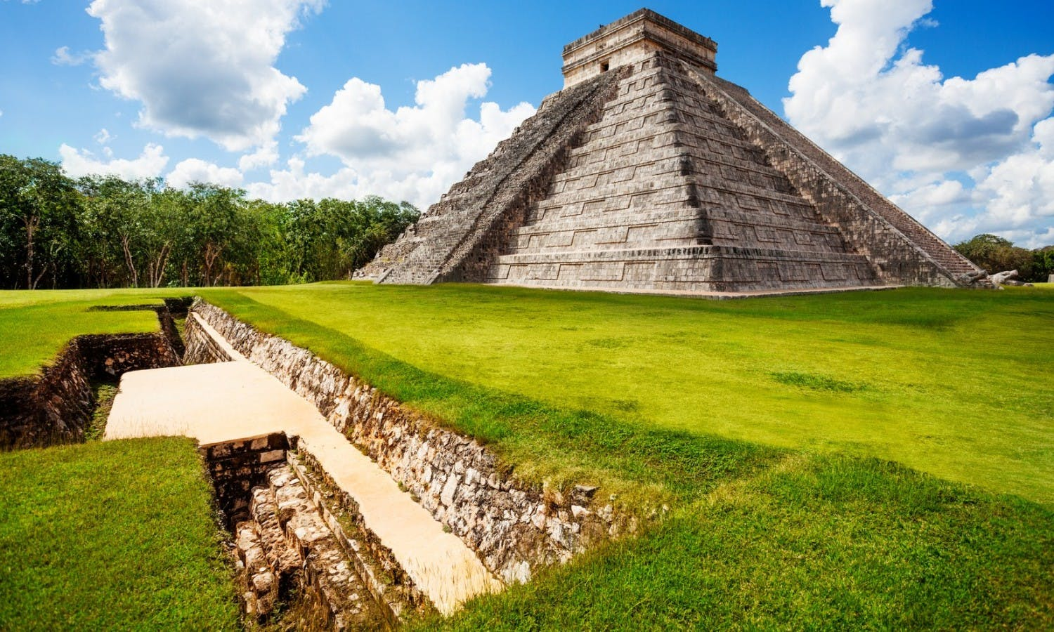
Sources
Schreiber., B. A. (2021). Chichen Itza | Description, Buildings, History, & Facts. Encyclopedia Britannica. https://www.britannica.com/place/Chichen-Itza
Team, M. F. (2021). Chichen-Itza. Tickets and Tours | musement. Musement. [Photograph] https://www.musement.com/us/cancun/chichen-itza-v/

State Park, Platte County, Wyoming
The park is located in Wyoming, USA near Glendo Town of Platte County and is not far from Douglas city. The park location is around the Glendo water reservoir, next to North Platte River. The park is attributed to the Oregon State culture and was at its height in 2017 during a total solar eclipse.
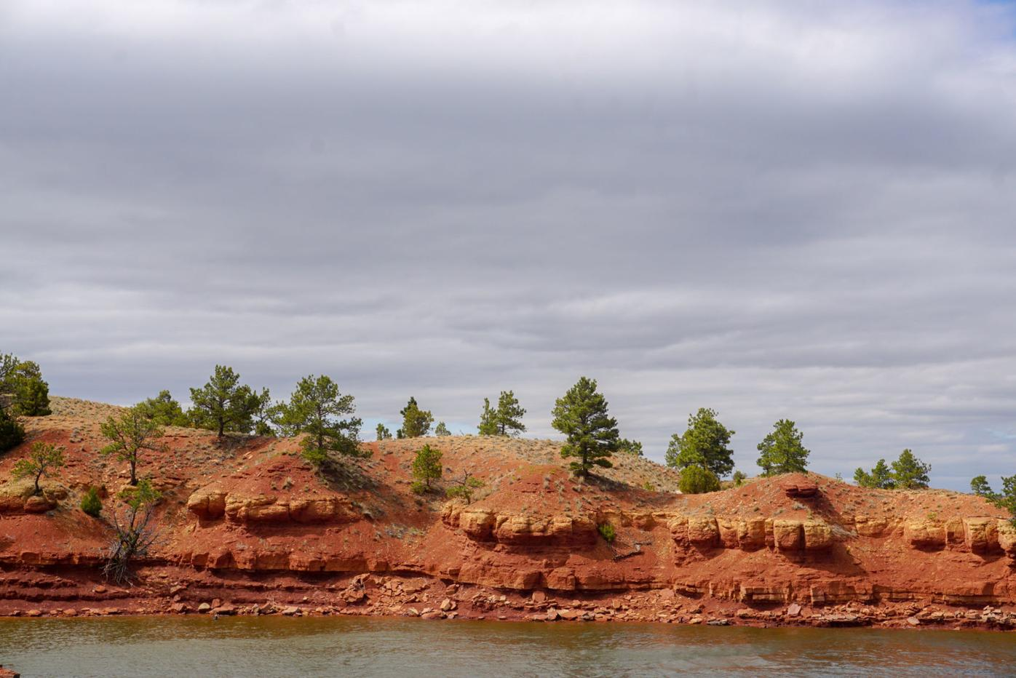
Sources
Miner, R. (2020). New pamphlet details geology in Glendo State Park [Photograph] https://www.wyomingnews.com/rocketminer/news/state/new-pamphlet-details-geology-in-glendo-state-park/article_d6c14431-2558-5803-ac58-d85e99528ff0.html
Wyoparks. (2021). Wyoming State Parks, Historic Sites, & Trails - Glendo State Park. Wyo Parks. https://wyoparks.wyo.gov/index.php/places-to-go/glendo
Ozette Indian Village Archeological Site
Ozette Indian Village is located in Washington, USA. Its location is near the bay of Neah and on the Olympic Peninsula. The village was occupied by people of the Makah culture in the 18th century before it was covered by a mudslide in the late 1900s.
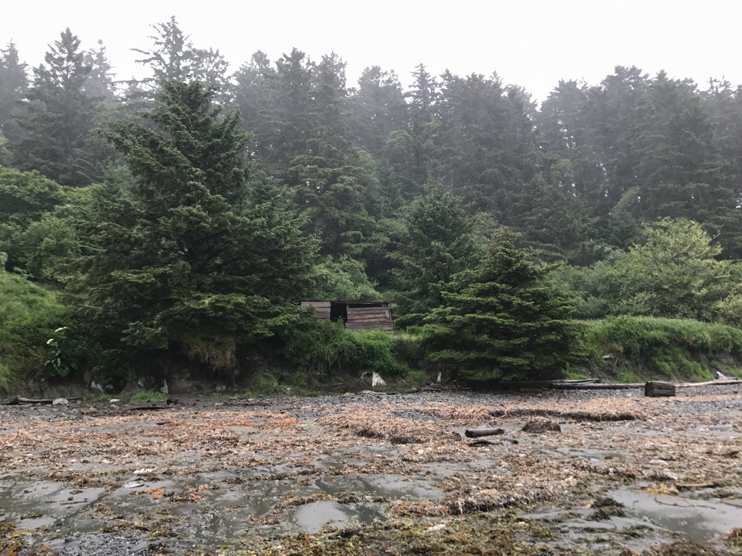
Source
Gruen, P. (2021, January 8). Ozette Archaeological Site. Sah Archipedia. https://sah-archipedia.org/buildings/WA-01-009-0042

Çatalhöyük Konya Turkey
The archeological site is found opposite the Konya plains and is to the South East of Konya city. The site is on the Anatolia Southern Peninsula and was at its height at around the year 7000BC. The Çarşamba River once flowed past the site. The inhabitants were known to belong to the Çatalhöyük culture and used the site to bury their dead.
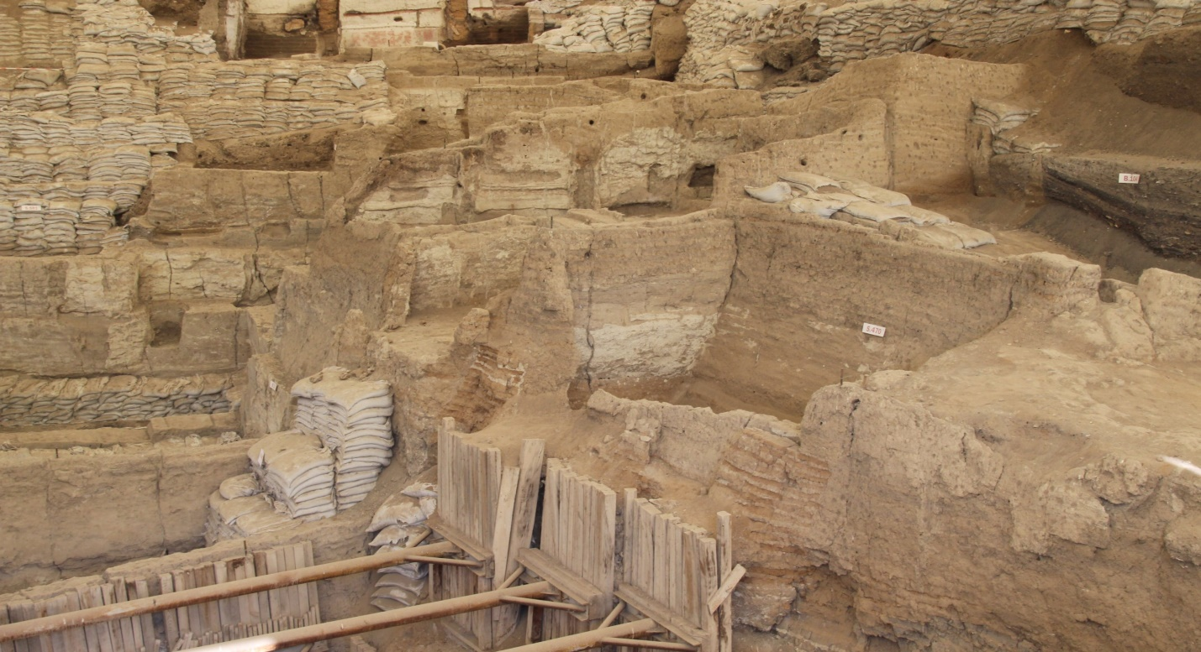
Sources
Anadolu Agency. (2021, July 14). Second neighborhood found in Turkey’s neolithic site Çatalhöyük. Daily Sabah [Photograph]. https://www.dailysabah.com/arts/second-neighborhood-found-in-turkeys-neolithic-site-catalhoyuk/news
Planet, L. (2019, October 23). Çatalhöyük | Konya, Turkey Attractions. Lonely Planet. https://www.lonelyplanet.com/turkey/central-anatolia/konya/attractions/catalhoyuk/a/poi-sig/1249461/360882
Poverty Point Webster Parish
The site is located in the southern part of United States in Northeastern Louisiana State. The construction of the site was done by people of the poverty point culture along the coast of the Mississippi river. The site is filled with mounds, ridges, canals and paths which scientists have not identified what they were used for. The mounds were built during the archaic period and have no ancient written record of their usage.
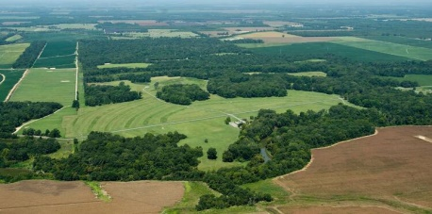
Sources
Poverty Point. (2021, May 2). In Wikipedia. https://en.wikipedia.org/wiki/Poverty_Point
UNESCO World Heritage Centre. (2014). Monumental Earthworks of Poverty Point [Photograph]. https://whc.unesco.org/en/list/1435/

Image 1
https://www.newshub.co.nz/home/shows/2018/11/auckland-s-albert-park-tunnels-have-to-be-open-before-the-america-s-cup-developer-bill-reid.html
Image 2
https://www.buriedvillage.co.nz/buried-village-of-te-wairoa-launches-new-website
Image 3
https://www.flickr.com/photos/kjelljoran/21618147398
Image 4
https://www.dreamstime.com/editorial-photography-viking-graves-borre-mound-cemetery-horten-norway-norwegian-borrehaugene-old-norse-words-borr%C3%B3-haugr-meaning-image64327342
Image 5
https://www.khm.uio.no/english/visit-us/viking-ship-museum/exhibitions/gokstad/
Image 6
https://www.bbc.com/news/world-europe-55145985
Image 7
https://bavipower.com/blogs/bavipower-viking-blog/viking-tune-ship-the-very-first-viking-ship-found
Image 8
https://www.alamy.com/archaeological-site-and-a-life-size-model-open-air-museum-of-iron-age-fortified-settlement-in-biskupin-poland-may-1st-2019-wojciech-strozyk-alam-image246148425.html
Image 9
http://www.slavia.org/slavia_project.php?go=excavation_giecz
Image 10
https://www.tripadvisor.com/Attraction_Review-g2538993-d3458199-Reviews-Augusta_Raurica-Augst.html
Image 11
https://www.alamy.com/roman-theatre-of-aventicum-avenches-vaud-switzerland-image264564920.html
Image 12
https://www.museumaargau.ch/en/legionary-trail/roman-sites
Image 13
https://www.sciencenews.org/article/massacre-sacred-ridge
Image 14
https://www.history.com/topics/landmarks/serpent-mound
Image 15
https://www.nps.gov/articles/hohokam.htm

